**Human Machine Interface (HMI ) Analytics - Manufacturing Sector**

GOKULNATH K & E24755

**Overview**

Human Machine Interface (HMI) Analytics in the manufacturing sector focuses on analyzing data from interactions between operators and machinery to improve operational efficiency. HMIs provide real-time insights into performance metrics, enabling quick decision-making and identification of bottlenecks. This analytics capability supports predictive maintenance, reducing downtime and enhancing product quality. Overall, HMI Analytics empowers manufacturers to optimize workflows and ensure safety in complex industrial environments.

**Objective**

1. **Real-Time Monitoring:** Enable continuous oversight of production processes by displaying real-time data on machine performance, operational metrics, and environmental conditions.
2. **Data Visualization:** Present complex data in an easily interpretable format (charts, graphs) to facilitate quick decision-making and enhance operator understanding.
3. **Process Control:** Allow operators to initiate, modify, or halt production processes directly through the HMI, ensuring flexibility and responsiveness to changing conditions.
4. **Error Detection and Troubleshooting:** Identify abnormalities in real-time and provide diagnostic information to assist operators in quickly resolving issues before they escalate.
5. **Predictive Maintenance:** Analyze historical data trends to predict equipment failures, enabling proactive maintenance that minimizes downtime and extends machinery lifespan.
6. **User Interaction Enhancement:** Improve operator engagement through intuitive interfaces that simplify input adjustments and settings management.
7. **Safety Management:** Display critical safety alerts and warnings to enhance operator safety and reduce the risk of accidents in the manufacturing environment.
8. **Training Efficiency:** Reduce training time for new operators by providing user-friendly interfaces that facilitate easier learning and operation of complex systems.

**Assigned Task(s)**

* Human Machine Interface (HMI ) Analytics - Manufacturing Sector.
* **Status:** Completed.
* **Details:**

1. Line Plot of Production Rate Over Time: Visualized hourly production rate trends for each machine.
2. Average Production Efficiency by Machine: Displayed machine-wise average production efficiency.
3. Operator Count Visualization: Showed the number of entries or usage frequency per operator.
4. Dual-Axis Plot for Temperature and Pressure Over Time: Plotted temperature and pressure trends simultaneously for process monitoring.
5. Average Downtime by Machine: Compared downtime averages across different machines.
6. Scatter Plot of Production Rate vs. Defect Rate: Analyzed correlation between production rate and defect rate for quality control.
7. Energy Consumption Over Time: Tracked energy usage trends over time to monitor operational efficiency.
8. Average Machine Uptime by Product ID Per Month: Displayed uptime patterns monthly by product for performance analysis.
9. Error Rate Over Time by Operator: Tracked operator-specific error rates over time for improvement insights.

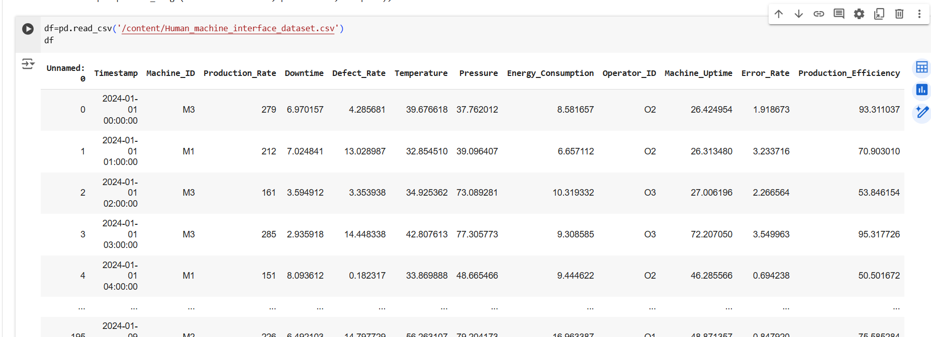

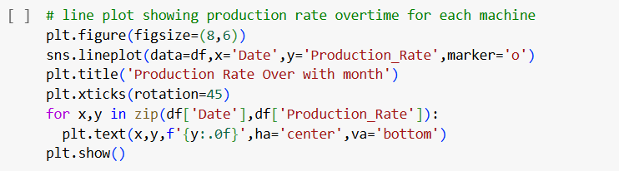

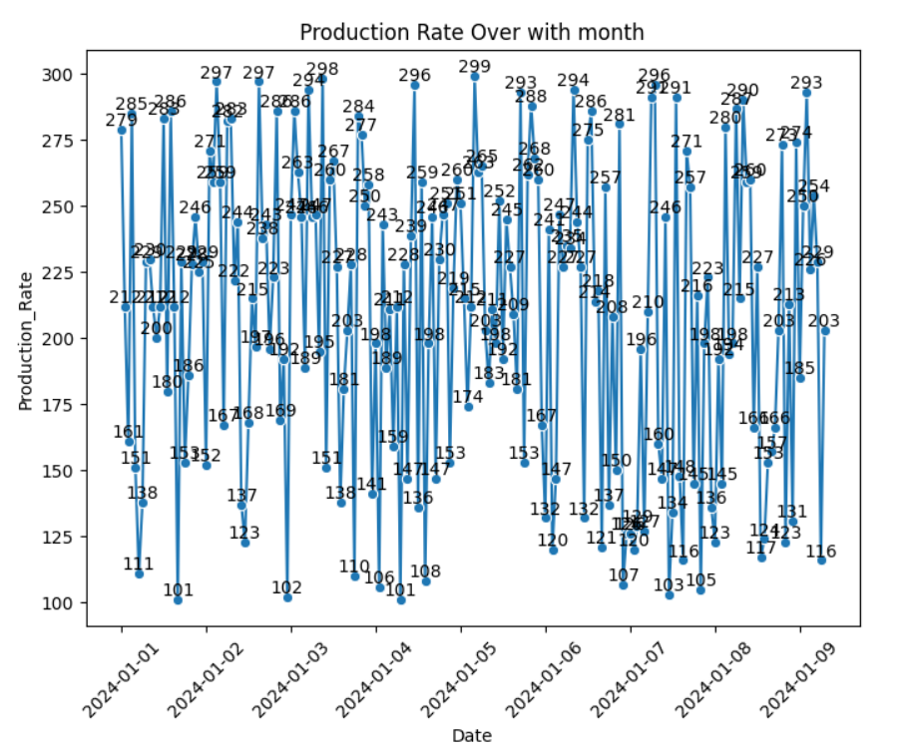

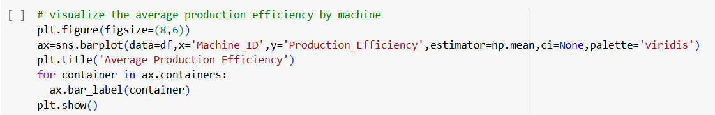

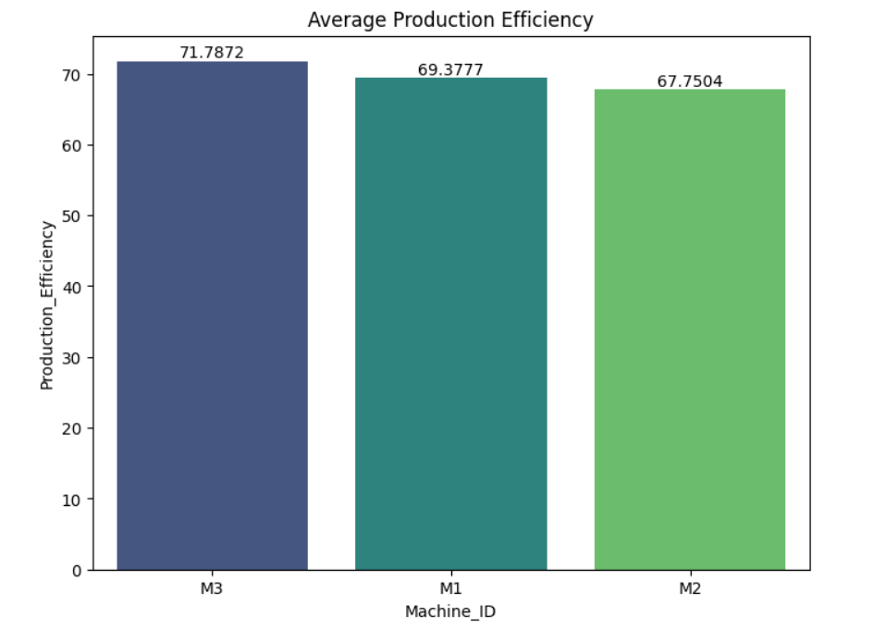

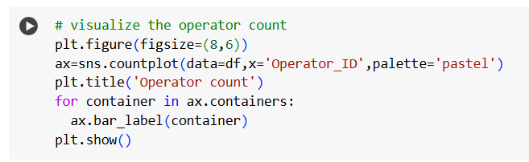

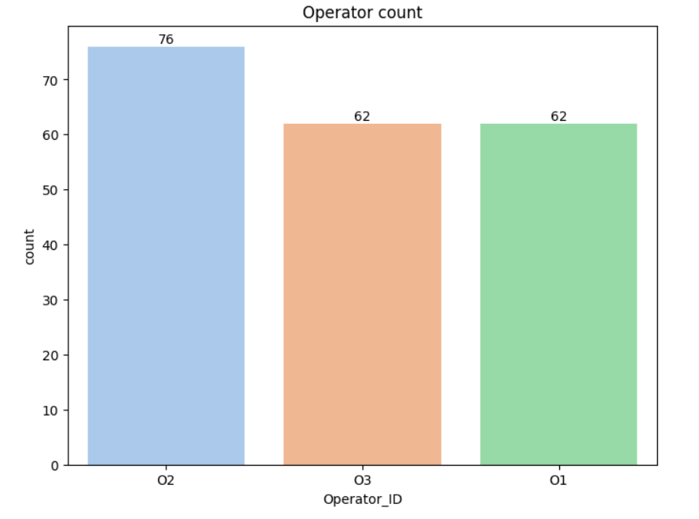

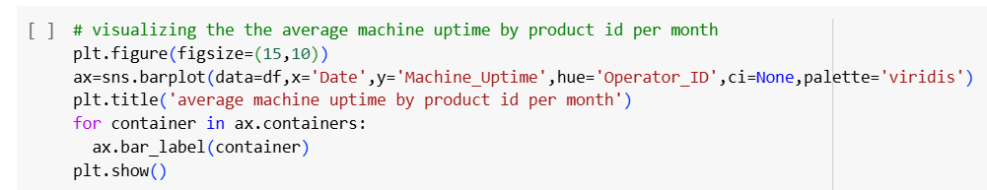

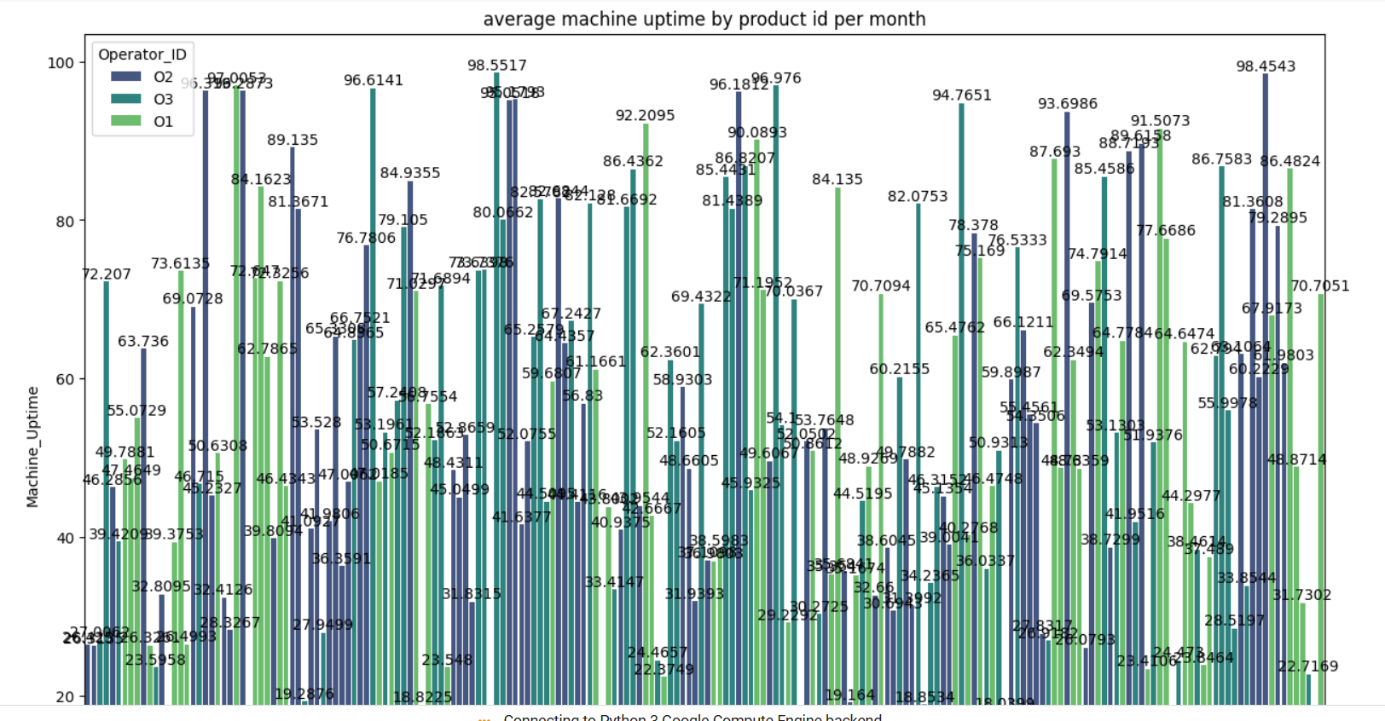

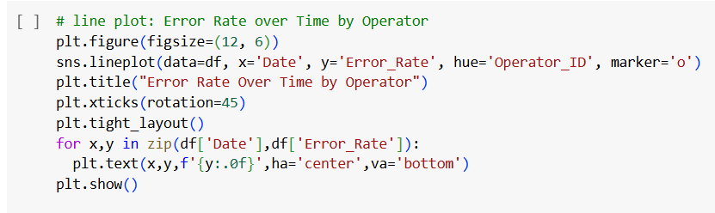

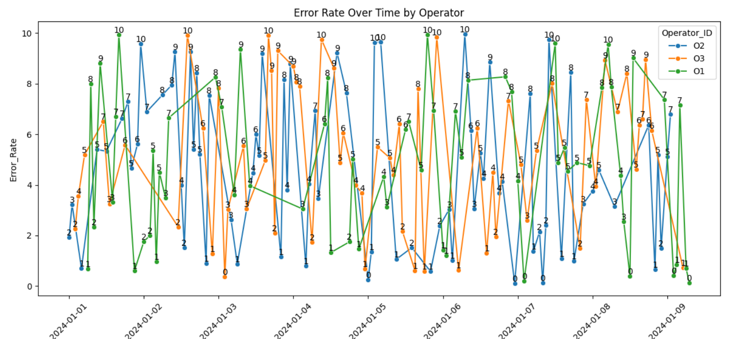

**Progress**

* **Accomplishments:** Accomplishments for this HMI analytics project include the development of detailed visualizations for production efficiency, machine uptime, and operator performance, enabling data-driven insights. Key metrics like downtime, energy consumption, and error rates were analyzed, providing actionable information for operational improvements. This analysis supports informed decision-making in manufacturing process optimization.
* **Metrics:**

1. Hourly rates tracked by machine to assess performance.
2. Average efficiency by machine as a percentage of maximum production.
3. Number of entries per operator to measure engagement.
4. Key process parameters monitored over time.
5. Average downtime per machine to identify maintenance needs.
6. Relation of production rate to defect occurrence.
7. Trend analysis for operational cost insights.
8. Monthly uptime by product ID for machine performance.
9. Operator-specific error rate to evaluate accuracy.

**Challenges and Solutions**

* **Challenges Faced:**

1. Variability in data from different machines or sensors.
2. Identifying root causes for high error or defect rates.
3. Managing large data volumes in real-time for timely insights.

* **Solutions Implemented:**

1. Implement data-cleaning processes to ensure consistency.
2. Apply statistical and machine learning models for accurate error predictions.
3. Use robust data pipelines and storage for real-time analytics.

**Next Steps**

* **Upcoming Tasks:** Approach upcoming tasks by focusing on data accuracy, leveraging automation, and optimizing processes for efficient, data-driven decision-making.
* **Goals:** Pursue upcoming goals by aligning analytics with operational targets, enhancing process efficiency, and driving continuous improvement.

**Conclusion**

* **Summary:** The HMI analytics in the manufacturing sector has provided valuable insights into production performance, efficiency, and quality control. By leveraging data visualization techniques, key metrics such as production rate, downtime, and energy consumption were analyzed effectively. Challenges were addressed through standardization and advanced analytics, enhancing decision-making capabilities. Overall, these efforts contribute to optimizing operations and driving continuous improvement in manufacturing processes.
* **Acknowledgments:** Thank you all for your attention and engagement. Your interest in Human Machine Interface (HMI ) Analytics - Manufacturing Sector.